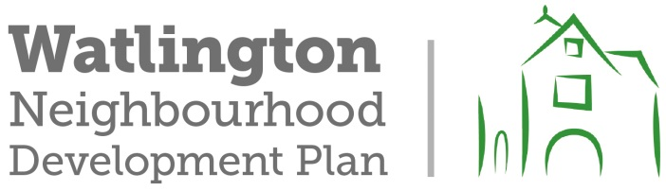
DRAFT EDGE STREET SPECIFICATION (FROM OCC)
- DMRB Standards, particularly in relation to horizontal and vertical (there is
significant gradient – impact on K values) curvature, forward stopping sight distance and junction visibility splays.
- Min 6.5m wide carriageway (kerbed both sides)---widened on bends where required
- Swept Path Analysis to demonstrate that 2x HGVs or buses can pass along the full route (refuse vehicle turning tracks to minor side roads to be contained in lane).
- Street lighting requirement to be included at all junctions (as a minimum requirement)….this may mean illuminating complete length
- 30mph design speed
- Side road junctions to include ghost island right turns (lane widths to be 3.25m through lanes and 3.5m wide ghost island, protected with illuminated splitter island).
- Min 3m shared ped/cycle route on the south side of the road.
- Min 2m footway on the north side of the road.
- Pedestrian/cycle crossing points as required to meet desire lines.
- Carriageway construction to be designed to HD26/06 (Foundation class min ¾ - Design nomograph 2.1 (in accordance with notes that refer) to be used. In any event all bitumen layers to HD specification)
- Priority adjustment to be incorporated at junction of Pyrton Lane and B4009 at northern end of edge road
- S278/38 agreement will be required for adoption of all additional highway asset (agreement will require a bond and 2 year maintenance period)
- Commuted sum for all additional highway asset will be required (this to include but not limited to: All carriageway, verge, drainage, electrical, street furniture, signs and lines, trees)
- Drainage to be designed to 1 in 100 year storm, plus 20% for climate change.

- Drainage to meet sustainable drainage standards – all development sites must be combined and holistic FRA must be produced
- Direct private drive access onto edge road prohibited
- Full paper title will be required over complete route of edge road prior to any highway agreement being put in place, this to include all visibility splays and any land required for drainage easements.

- All highway structures must follow BD2/12 design and construction procedure (significant bridge/culvert structure will be required immediately south of Cuxham Road)
- Area south of Cuxham Road is designated flood zone 3 (Watlington has suffered significant flooding in recent years)
o How will this be mitigated
o EA approval required
- Flood risk assessment will be required

As submitted to the WNDP by Jason Sherwood

Locality, Infrastructure & Road Agreements Manager
Infrastructure Innovation and Development
Communities
Oxfordshire County Council

