  - Watlington Green Spaces

Post Examination Version

‘Our Community… Our Plan’

Document:
WNDP 10

Watlington Parish Council
April 2018

Green Spaces and Rights of Way Watlington

Green Spaces
There are a variety of green spaces and recreational facilities in Watlington. The spaces are important assets for the town, providing different opportunities for sports, recreation, relaxation and social wellbeing for all people of all ages. The green spaces and associated recreational facilities are very well used and contribute significantly to the character and visual amenity of the town.
They are also important for their bio-diversity and range of natural habitats.

In view of the high amenity value and levels of use of the sites within Watlington and its surrounds, it was concluded that the larger sites should not be put forward for development. The Parish Council will be seeking to designate relevant areas as Local Green Spaces.

Green Spaces Map

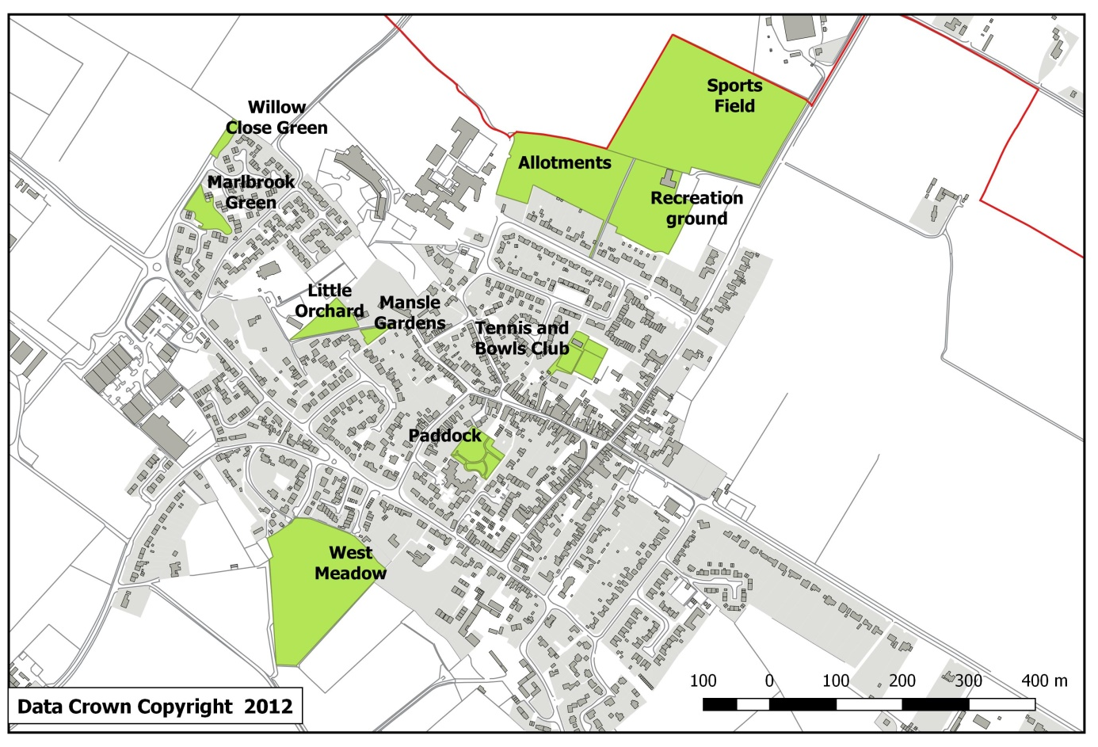
All maps contain Crown Copyright Data ©, Crown Copyright and Database Right [2012] and have been prepared by Watlington Parish Council under the PSMA agreement 0040083989. These maps may not be reproduced in any form without explicit approval from Ordnance Survey Limited and Watlington Parish Council.
Figure 1: Areas to be designated as Local Green Spaces

A summary of key spaces with high amenity value is detailed below:

Spaces for recreation, relaxation and social wellbeing within or in close proximity to the main town built up area. Many of these areas are also rich in wildlife.
Green Space | Responsible body | Notes
St Leonard’s Churchyard | Church of England | Graveyard is operational  Space for quiet contemplation for all ages  Space for fetes and festivals
Mansle Gardens | Parish Council | Area for contemplation and relaxation used by young children & carers and elderly residents
The Green, Marlbrook Estate | Parish Council | Used by local residents as a recreation space, including for social gatherings  Accessible by residents with mobility issues living in bungalows around the green
The Paddock  Community Garden | Parish Council | Space for recreation and relaxation  Play area with equipment for young children  Daily use by all ages
The green at the Lilacs |  | Used by local residents as a recreation space
Allotments | Parish Council | There are approximately 70 allotment holders and all allotments are in active use
Little Orchard (Masons Wood) | Freemasons Icknield Masonic Lodge | Area for wildlife with public access *
Horse Ponds | Private Ownership | Public footpath through the land  Amenity for walkers and dog walkers
West Meadow | Charitable Trust | Trust have confirmed that they have no plans to apply for development. Very well used area for walkers and dog walkers, with trees and mature hedgerows.

*The public have had free access to this small area of woodland for many years but the Masonic Lodge had concerns over access and put up boundary fencing on 01/07/2017. The area is important locally for the habitat it provides and bio-diversity it supports. Watlington Parish Council is in dialogue with the Icknield Masonic Lodge with a view to securing the woodland for the benefit of the community.

Spaces for sports activities within the main town built up area
Green Space | Responsible | Notes
Shirburn Road Recreation ground & Pavilion | Parish Council | Skateboard park, ‘trim-trail’, play equipment.  Hard play area with goals  Daily use by children of all ages  Space for young people to meet up at weekends and in the evenings
Shirburn Road Sports Fields | Parish Council leases the sports fields | Sports fields are extensively used for combined purposes including football, cricket.
 | Football | Approx. 120 children from Watlington and surrounding areas. Matches Saturdays and Sundays  Soccer School training groups U5s / U6s  8 x junior teams under (U7’s x 2, U8, U9, U10, U11, U12, U14)  Approx. 100 adults involved in football with the club  3 x adult teams – men’s open & 2 veterans teams  Mens open training sessions Tuesdays 16+  Ladies training sessions Tuesdays  Affiliated to local leagues  There is an unmet need for the provision of adult and evening football
 | Cricket | Senior team  2 x junior teams  Affiliated to Oxfordshire Cricket Association  Regular training sessions
Watlington Club | Charitable Trust | Aunt Sally, Darts, Pool, Tai Chi, Judo, 2 x squash courts, Slimming World, Senior circuits, dance and social area  Outside space – tennis, bowls
Watlington Club  Tennis Club | Charitable Trust | 3 tennis courts, 2 x floodlit, courts available for use throughout the year  Club sessions Saturday mornings and Wednesday evenings  Junior sessions Friday and Sunday evenings  Men’s, ladies, mixed teams in Oxfordshire leagues. Summer knockout tournaments  Matches played at weekends  Adult and junior coaching  Visitors welcome
Watlington Club  Bowls Club | Charitable Trust | Ladies and men’s sections  Approximately 60 members ages ranging from early teens to 90  Club and County competitions played April - Sept
Icknield Community College & Primary School playing fields | OCC | Fields used for school sports and afterschool and holiday club activities

Spaces outside the built-up area of the town
Green Space | Responsible | Notes
Willow Ponds | Copas Farms | Very popular destination for local walks with a permissive path and links to local rights of way.
Chalk Pits | Parish Council. Managed by the Watlington Environment Group | Local Wildlife Site, and most is also SSSI. It is designated for its biodiversity, habitats and natural interest

Areas to be designated as Local Green Spaces in the Watlington Neighbourhood Development Plan:
- West Meadow
- The Paddock Community Garden
- Watlington Club Bowling Green and Tennis Court
- Allotments
- Recreation Ground
- Sports Field
- Mansle Garden
- Little Orchard (Masons Wood)
- Marlbrook Green

These nine sites are shown in Figure 1. For further information about these sites see Appendix A.

Rights of Way

Pedestrian and cycle access will be a key means of promoting integration of new development sites and the existing built environment of Watlington. The WNDP has identified a number of opportunities to protect and develop the footpath and bridleway network, which are detailed below.
These will be considered over the period of the WNDP and will be promoted by the Parish Council as priorities are agreed for the use of the local share of the Community Infrastructure Levy.

- PROTECTING THE EXISTING NETWORK
There are several footpaths that do not have the security of being on the definitive map. For the long-term protection of paths the Parish Council will seek legal protection for the following paths:
- Johnson's Alley (F2)
- Pilgrims Cottage Brook St to Watcombe Road (F3)
- Extension of footpath W28 between Britwell Road and Cuxham Rd (F5)
- Brook St to Brookside (F4)
- Church Pound to St Leonard's Close (F6)
- Britwell Road to Hurdlers Green (F7).
These possible additions to the town footpaths are shown numbered as F<n> in Figure 2 along with existing footpaths and bridleways.

- RESTORING ACCESS TO ROUTES THAT ARE NOT CURRENTLY OPEN
A 30 foot public carriageway is shown on the Inclosure Award running in a SW direction from Watcombe Manor to the Parish boundary. This route would make an important addition to the network in Watlington as it would join/cross footpath W 13 and so public access to the route should be restored.

- ALLOCATED IMPROVEMENTS INTO THE TOWN CENTRE FROM POTENTIAL DEVELOPMENT SITES
Due to the built-up nature of the Town there is limited scope for expansion of rights of way, but the following possibilities could be considered:
- If Pyrton Lane ceases to be a through route and Willow Close is not incorporated into the alternative route for the B4009, it would seem feasible to create a footpath/ cycleway from Willow Close, across Pyrton Lane along the edge of the Primary School grounds and join Chapel St (F10). Such a route to the Town would be most useful for potential residents on housing sites B and C.
- Formalise the well-used footpath (F11) along the side of the field adjoining the allotments to join up with the Recreation Ground. Better surfacing would be required along the length of the path including the section at the Pyrton Lane end (Pyrton 6).
- If housing site A is developed it will be important to look carefully at a formal crossing point near the roundabout by the Industrial Estate.
- Pavement widths and continuity of pavements are currently very poor in several parts of Watlington, especially in Cuxham Road and part of Britwell Road. Options for improving safety for pedestrians will be investigated during the period of the WNDP.

- IMPROVING ACCESS OUTSIDE THE TOWN CENTRE
There are a number of connecting routes that could be developed to improve pedestrian access outside the town centre.

- Create a path from the end of the Recreation Ground to the B 4009 / Station Road alongside the B4009 but within the boundary of site PYR1 (if this is developed).
- Create a safer short route along the B 480 between footpaths W 11 and W 10 on Howe Hill
- Create a link between bridleways W 22 and W 9
- Create a safer route between footpaths W 6 and 7 to avoid the need to use Hill Road
- Create a branch link from footpath W 12 to the Icknield Way
- Create a link from Watlington Hill car park and footpath W 4
- Extend footpath W 11 at the Britwell Parish boundary to the Icknield Way
- Create a safer route between the Icknield Way and footpath W 6 along the B480 or inside the adjoining field.

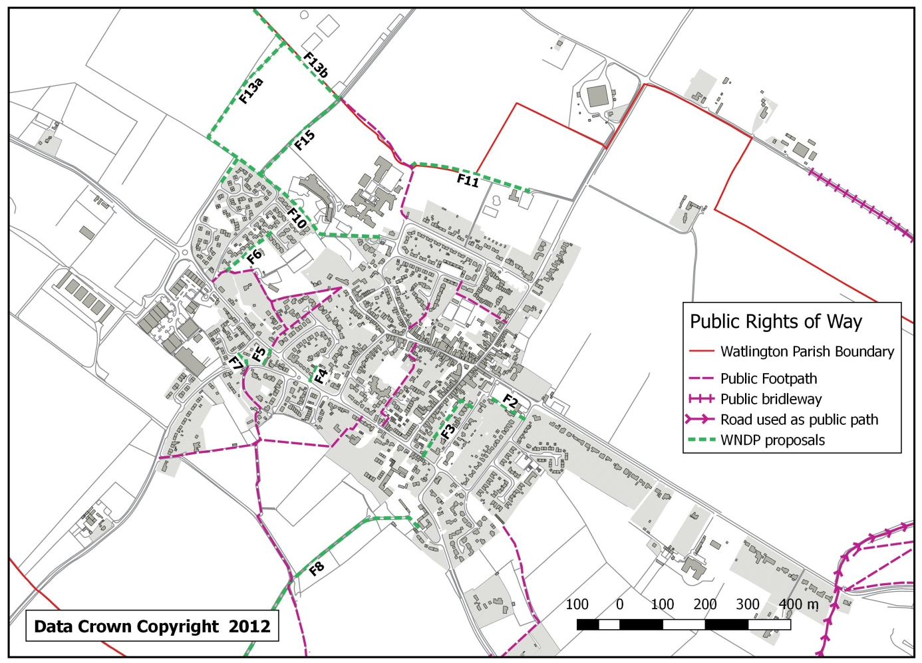
Figure 2: Town area footpaths Those labelled as Fn are proposed new paths.

- IMPROVING ACCESS TO NEIGHBOURING COMMUNITIES
Watlington has many footpaths leading towards the Chiltern Hills, but lacks direct footpaths to villages to the west of the town. Some possible route are shown in Figure 3.
CUXHAM
There are two possible new routes , both have been used informally . The first (C1) takes a NW direction along the field edge from the end of Willow Close , turns NE at the field boundary until the Parish boundary is reached , and follows this boundary until joining the footpath from Pyrton (Pyrton 8). The second (C2) follows the track from the Parish boundary on Pyrton Lane (a continuation of Pyrton 6) until the Pyrton footpath is reached (Pyrton 8).
Local research has identified that there is sufficient space along SW side of the B480 to establishing a footpath linking Cuxham and Watlington (C3). This clearly warrants further study and discussion with Cuxham and OCC
BRITWELL SALOME
The most obvious route (F8 and B1) would be from Watcombe Manor (assuming the re-opening of the route to the Parish boundary) and continuing until Shakespeare Way is reached (bridle path Britwell 12) or preferably the Britwell Hill / Britwell Road is met.

PYRTON
Assuming the alternative route for the B4009 is built and is doesn't incorporate Pyrton Lane, the existing Pyrton Lane (beyond St Leonard's Close) could become a quiet road (P1 & P2) without vehicular traffic. This would result in improved conditions for horse riders, cyclists and pedestrians. There would need to be a crossing point of the ‘new’ section of B4009 at some point.
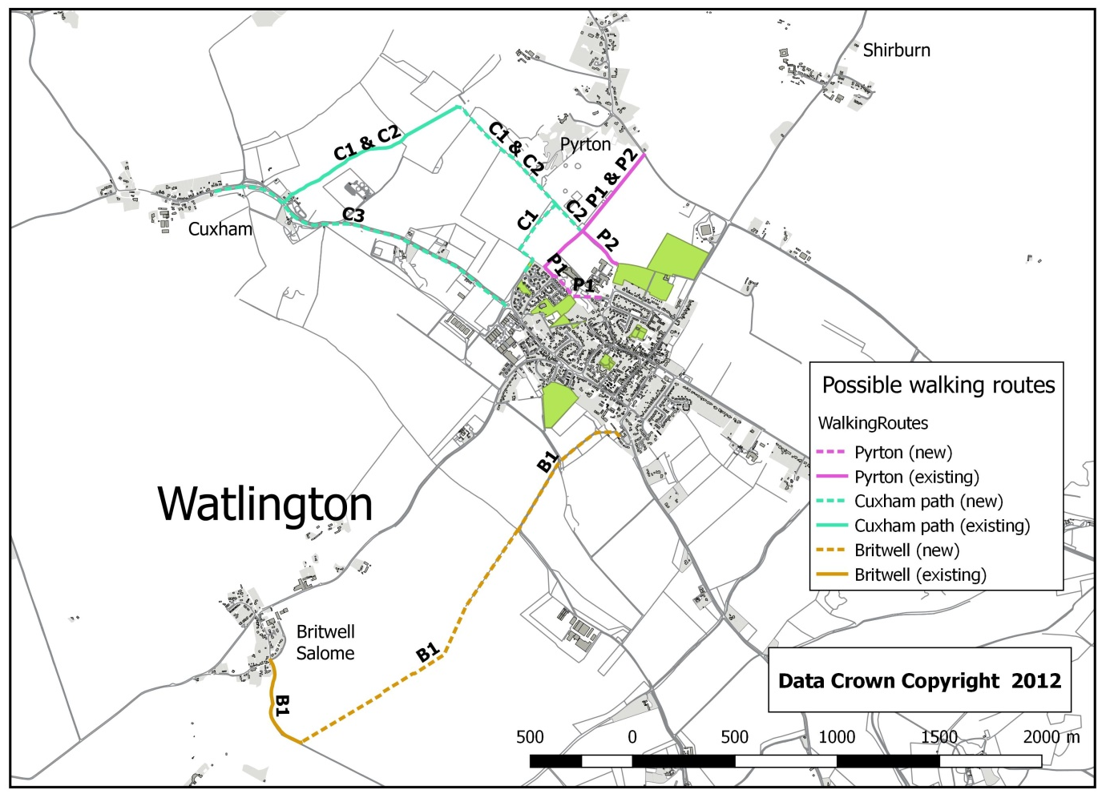
Figure 3: Possible walking routes to neighbouring villages

- IMPROVEMENT TO SURFACES OF WELL USED PATHS
The worst section in this category is the 200m + of footpath W13 along the brook from the Willow Ponds. Options to improve the surface of this section should be investigated, including bringing in stone to improve the surface. Funding for this work would not be met by OCC but they would have no objection to it in principle. It may also be necessary to consider improving the surface of footpath W 12 to the south of the horse ponds if the planned cutting back of overhanging vegetation is not sufficiently effective in drying the surface of the path in winter.

- OTHER POSSIBLE IMPROVEMENTS
- Improved crossing point on the B480 Howe Road from footpath W12 to footpath W13b.
- There also may be the possibility of converting the old railway track to Lewknor into a cycleway
- Improve the surface of the Icknield Way between Hill Road and Station Road.
- ACCESS
Access for those with impaired mobility should be built into all improvements in pedestrian routes.
- BRIDLEWAYS
- The proposed re-alignment of the B4009 will have an impact on the local bridleway network.
- Safe routes will be needed to the Icknield Way and existing bridleways in Pyrton
- Provision for a new bridleway could be made alongside the new B4009 route.
- Safe crossing points will be needed.

Appendix A: Proposed Local Green Space designations

Site Details
West Meadow | SU686943 | Open meadowland – previously flood plain for now-diverted stream. Crossed by footpaths leading to popular rural walks. Meadow used by many for exercising dogs. Owned by the Watlington Charities.
Checklist
Statutory designations |  | Site allocations | Planning permissions
Within Watlington Conservation Area |  | This NDP recommends site for allocation as Local Green Space | No current or previous planning applications.
NPPF Criteria
Close to the community |  | Demonstrably special | Local and not extensive
About a third of the perimeter of the site adjoins two housing areas in the town. There are two formal footpaths which lead from the housing into the Meadow, and a third informal entrance from Allnut Close. |  | This site provides a large open green area that is ideal for exercising dogs, and is well used for that purpose. In addition to this recreational purpose, the meadow includes the course of an intermittent stream from the Willow ponds into Chalgrove Brook, and has the potential to be used for flood protection. The stream is now diverted around the field. | The area is owned by a local charitable trust. It has an area of 2.4ha, and is all open meadow used occasionally for grazing cattle by a local farmer.
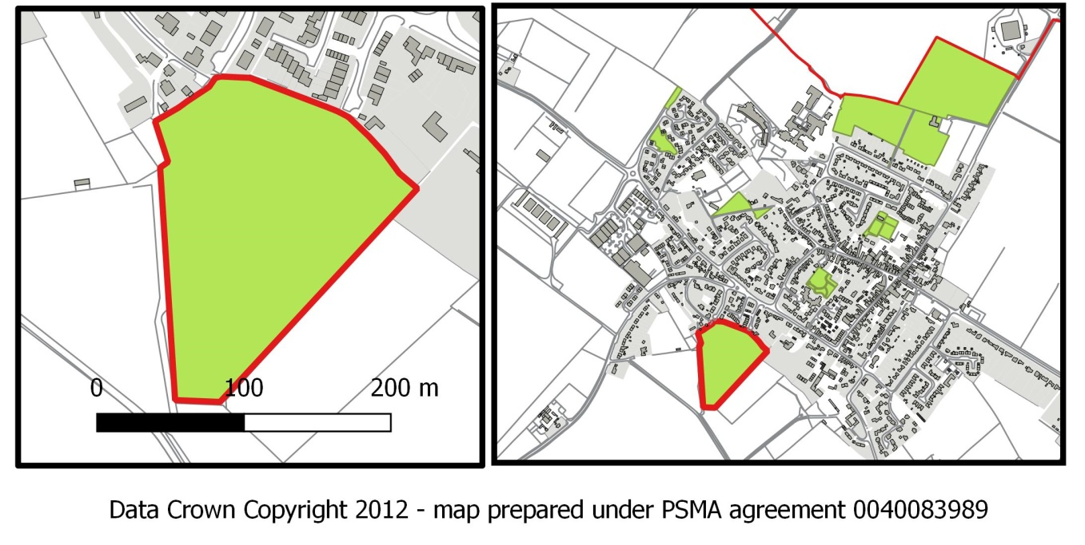

Site Details
The Paddock Community Garden | SU688945 | Formal park with play area for younger children. A restful, well planned area in the middle of town used by people of all ages. Owned by the Parish Council.
Checklist
Statutory designations |  | Site allocations | Planning permissions
Within Watlington Conservation Area |  | This NDP recommends site for allocation as Local Green Space | This site has not previously been developed, but was attached to the primary school as a playground until about 18 years ago.
NPPF Criteria
Close to the community |  | Demonstrably special | Local and not extensive
Enclosed within the built-up area of the town, and adjacent to SOHA housing for older people. The Paddock is in the middle of town within 50 meters of the High Street. |  | The Paddock was developed from the old school playground specifically as peaceful garden and recreation space within the town. It has a number of mature trees as well as numerous benches and a small play area with equipment for younger children. The lawn areas are frequently used for outdoor events by local groups. | It has an area of 0.35 ha. The aim of proposing it as a Local Green Space is to protect it as a natural asset for future generations.
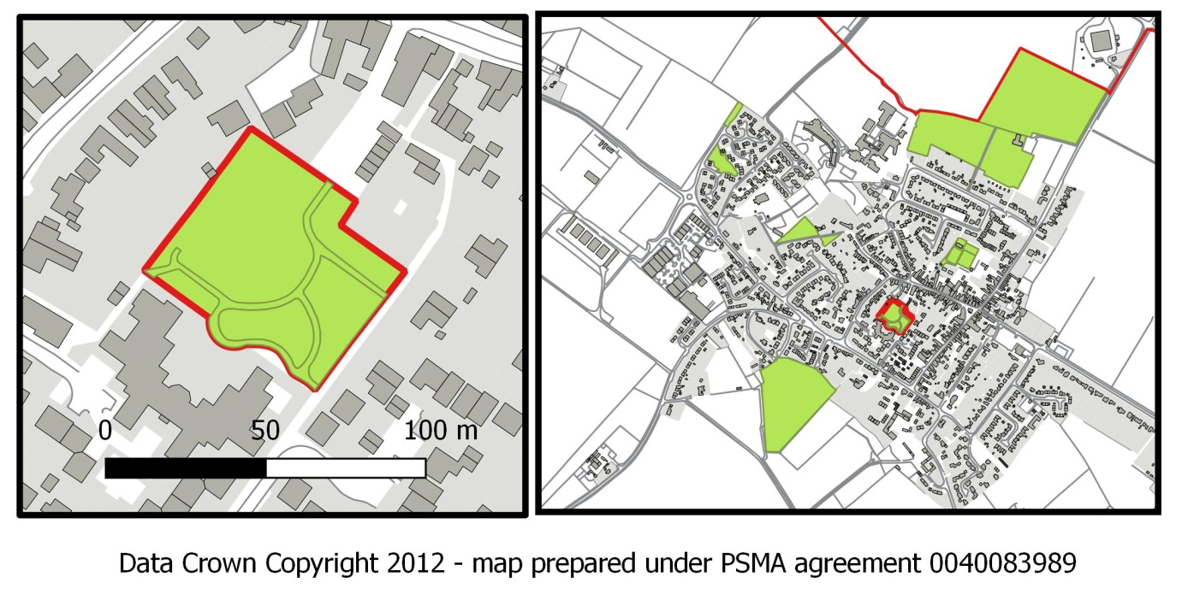
Site Details
Watlington Club Bowling Green and Tennis Court | SU689946 | Sports facilities run by the clubs affiliated to the Watlington Club, a charitable trust
Checklist
Statutory designations |  | Site allocations | Planning permissions
Within Watlington Conservation Area |  | This NDP recommends site for allocation as Local Green Space | There is a clubhouse for the Bowls Club on this area and the Tennis Club have a small pavilion immediately adjacent to its eastern edge. There are no planning applications currently open.
NPPF Criteria
Close to the community |  | Demonstrably special | Local and not extensive
Enclosed within the built-up area of the town, and connected to the Watlington Club (previously the Watlington Memorial Club) on the High Street.Adjacent footpath between current residential areas and the town centre. This footpath will be a significant route for at least two of the three sites allocated in this NDP. |  | These two clubs are part of the Watlington Club, with the complex forming an important social focus for the town. Watlington Club was established following the 1914-1918 war as a memorial to those killed in that war.Both Bowls and Tennis Clubs are very active. | The green area in this proposed designation has an area of less than 0.4ha, but this is only part of the land owned by the Watlington Club, with the remainder providing a car park, a small open grassed area used for outdoor eating and drinking, and the main Club building which includes function room used by many organisations, as a well as a squash club.
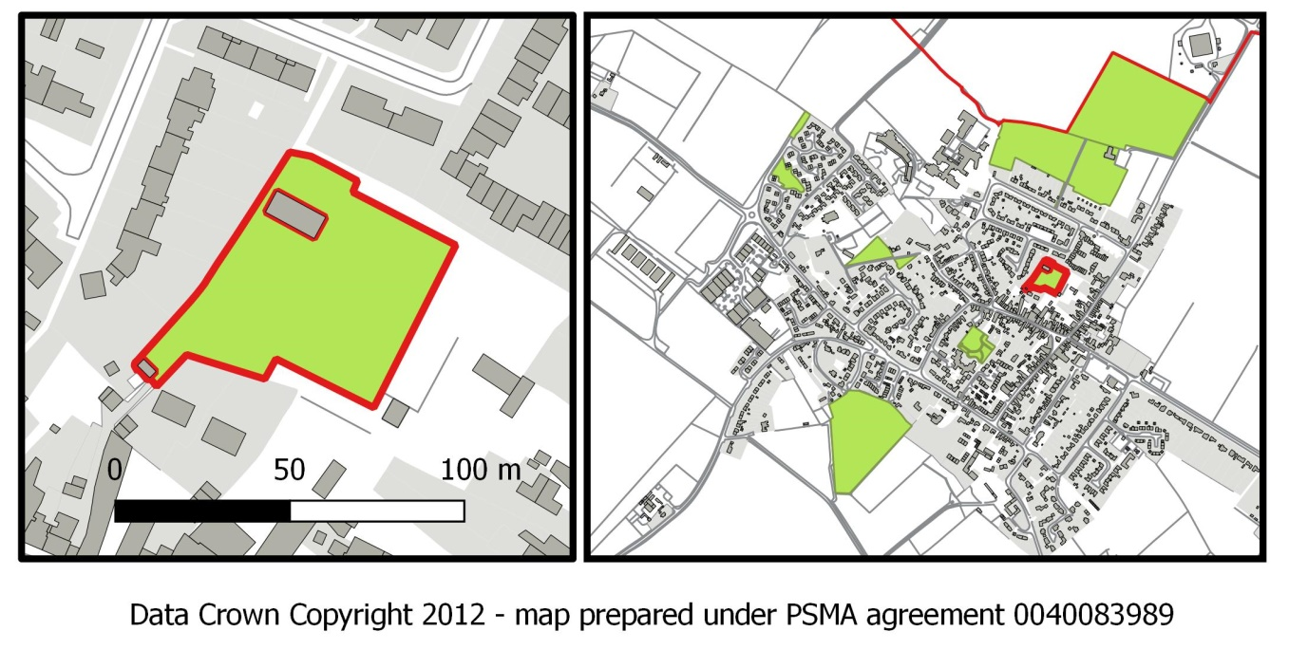
Site Details
Allotments | SU688949 | Public allotments, well maintained and popular. Owned by the Parish Council
Checklist
Statutory designations |  | Site allocations | Planning permissions
No designation |  | This NDP recommends site for allocation as Local Green Space | No current or previous planning applications.
NPPF Criteria
Close to the community |  | Demonstrably special | Local and not extensive
The allotments site is on the northern edge of town with half of its perimeter adjacent to housing, the Recreation Ground or Icknield College. It is owned by the Parish Council and run by a committee of volunteers. |  | This is the only remaining public allotment site in the Parish. It is fully used with over 70 individuals or families having whole or part allotments, and with periodic waiting lists for those wishing to obtain a plot. It has been used as allotment land for at least 50 years. It’s an important area for wildlife and provides a range of natural habitats. | The full site has an area of 1.7 ha including driveways, paths and a small area of hazel coppice on the less fertile land. This is divided into a number of full, half and quarter size allotments let to local residents.

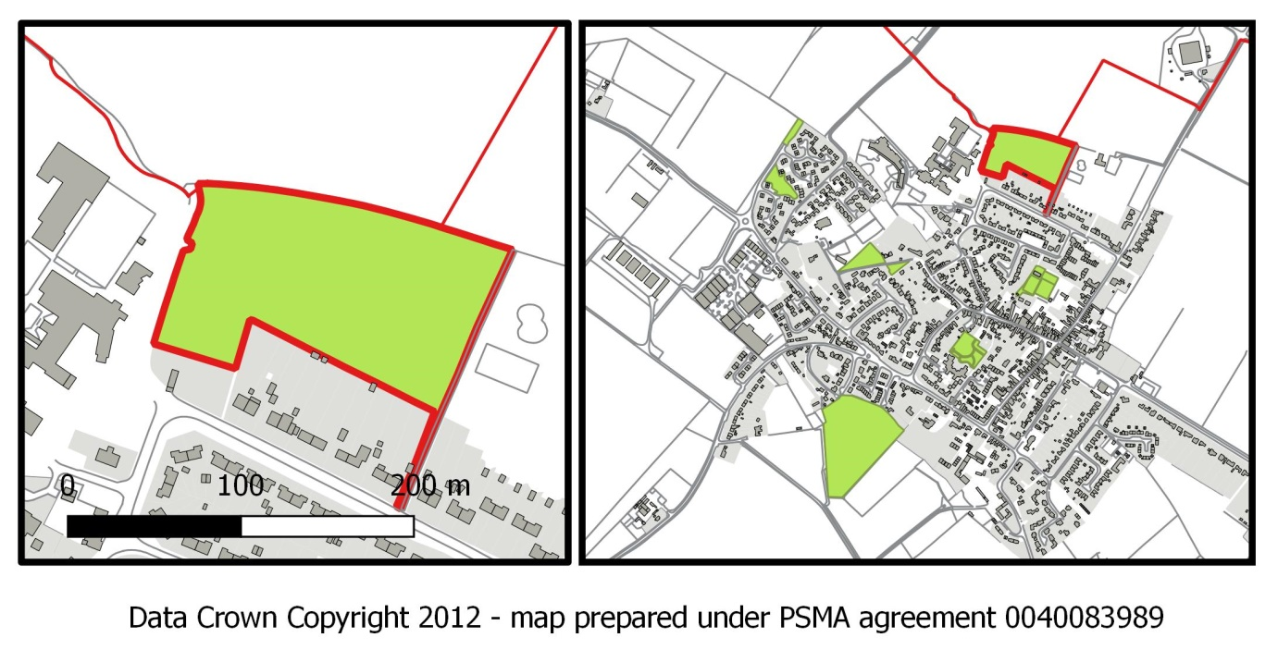

Site Details
Recreation Ground | SU691949 | Public recreation area with children’s play equipment, adult fitness equipment, skatebowl and half-pipe, and large open area. Owned by Parish Council
Checklist
Statutory designations |  | Site allocations | Planning permissions
No designation |  | This NDP recommends site for allocation as Local Green Space | A sports pavilion was built in 2005 to replace the previous inadequate changing facilities. There are no current planning applications.
NPPF Criteria
Close to the community |  | Demonstrably special | Local and not extensive
The recreation ground is on the edge of town but contiguous with the houses along Love Lane. For pedestrians it is 350m from the centre of town and no more than 1km from the most distant houses in town. |  | It is an open field with some trees along its south-western and south eastern sides. It has a range of play equipment covering all ages, including adult fitness equipment. It is well used by residents of the town, but also attracts people from the wider area because of the range of facilities available. The Pavilion is used by the sports club and other local organisations and is also a popular venue for children’s parties. | The recreation ground has pedestrian access from Love Lane and vehicle access from Shirburn Road. It has a small car park with a capacity for 25 cars. The site including both the car park and the Pavilion has an area of 1.1ha. It is owned by the Parish Council, and has been used as a recreation ground for more than 40 years.

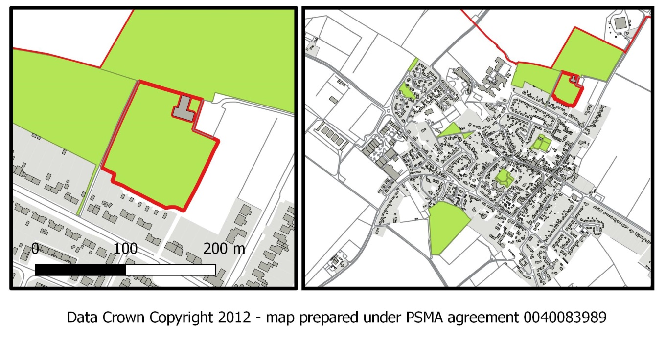
Site Details
Sports Field | SU692950 | Cricket and football sports fields in regular use throughout the year. Managed by Watlington Cricket club and by Watlington Town Football Club, owned by Beechwood Estates, a local landowner. Leased by the Parish Council on a 50 year lease.
Checklist
Statutory designations |  | Site allocations | Planning permissions
No designation |  | This NDP recommends site for allocation as Local Green Space | No current or previous planning applications.
NPPF Criteria
Close to the community |  | Demonstrably special | Local and not extensive
The sports fields are on the edge of town and form an extension to the Recreation Ground. For pedestrians it is less than 1 km from the centre of town. |  | Both the Cricket Club and the Football Club are very active, fielding a couple of adult teams each, and with junior sections that attract a large number of children for both training sessions and matches. Both clubs have started women’s sections. The Parish Council and Sports Clubs have made significant investments in the sports facilities over the past decade. | The recreation ground has pedestrian access from Love Lane and vehicle access from Shirburn Road. It shares a small car park with a capacity for 25 cars. The site has an area of 3.9ha and is large enough for both cricket and football fields, as well as some practice areas. It is leased by the Parish Council, on a 50 year lease signed 1997, with an option to extend the lease for a further 50 years.
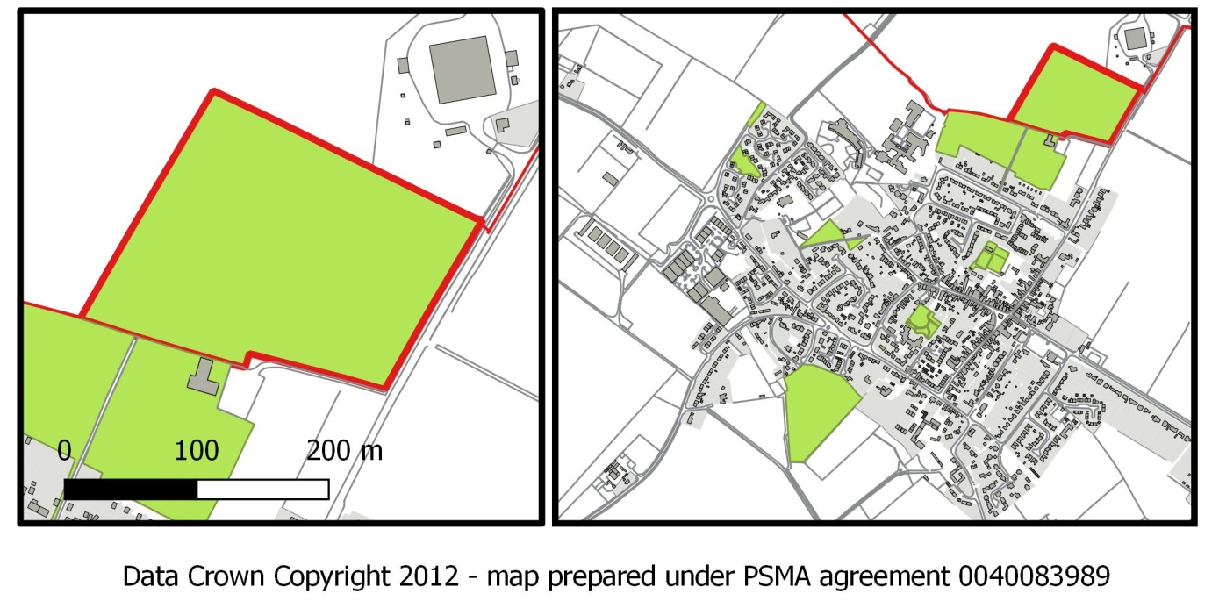

Site Details
Mansle Garden | SU686947 | Small informal garden and greenspace area used as a quiet place for people to relax. Owned by the Parish Council.
Checklist
Statutory designations |  | Site allocations | Planning permissions
Within Watlington Conservation Area |  | This NDP recommends site for allocation as Local Green Space | No current or previous planning applications.
NPPF Criteria
Close to the community |  | Demonstrably special | Local and not extensive
This park is entirely enclosed within the built-up area of the town. It is accessed from the end of Church lane, the ancient route to the church, and is bounded on the west by a footpath from the end of Church lane leading to the church. This footpath will be a significant route for at least two of the three sites allocated in this NDP. |  | This small area of parkland was given to the Parish Council for the benefit of residents and has been made into a quiet restful corner on the edge of town, with benches and areas of grass and wildfowers. It is named for our twin town, Mansle, in France. | It has an area of less than 0.1 ha. The aim of proposing it as a Local Green Space is to protect it as a natural asset for future generations.
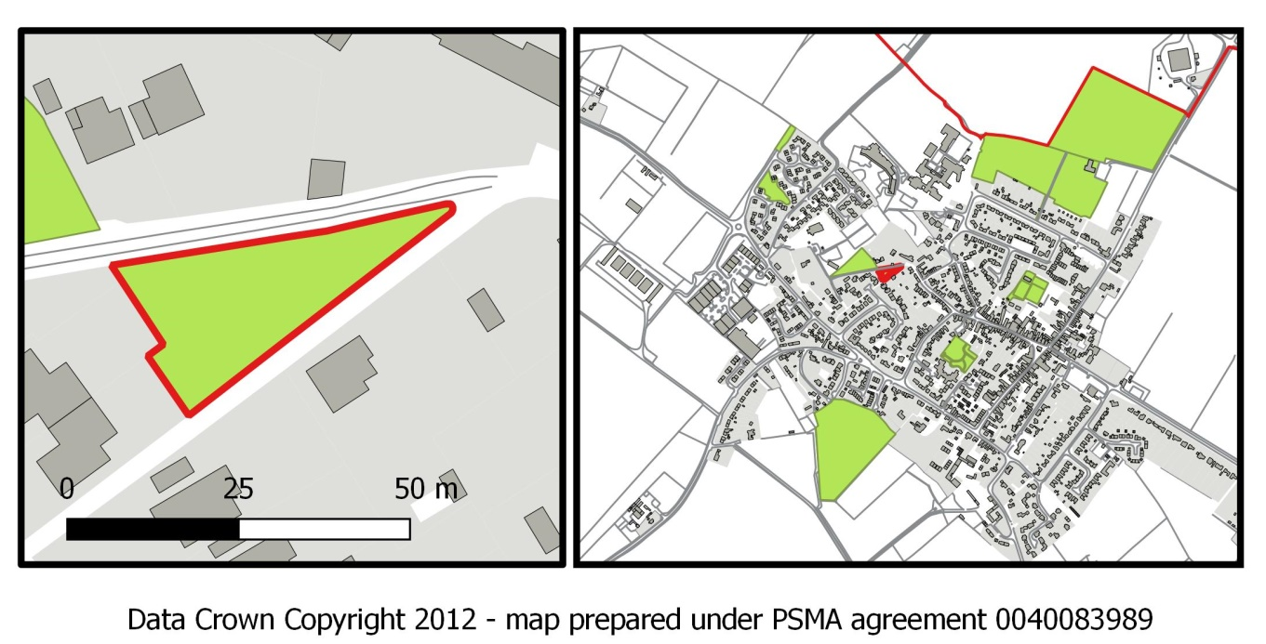
Site Details
Little Orchard (Masons Wood) | SU685946 | Area of urban woodland, crossed by informal paths. Owned by the Freemasons Icknield Masonic Lodge.
Checklist
Statutory designations |  | Site allocations | Planning permissions
Within Watlington Conservation Area |  | This NDP recommends site for allocation as Local Green Space | No current or previous planning applications.
NPPF Criteria
Close to the community |  | Demonstrably special | Local and not extensive
Enclosed within the built-up area of the town. Adjacent footpath between current residential areas and the town centre. This footpath will be a significant route for at least two of the three sites allocated in this NDP. |  | This is the only remaining area of unspoilt woodland in the town. It is well used by local residents, especially children, as a wilderness area for playing, exploring, exercising dogs or just admiring the wild flora and bird life. This area of woodland is irreplaceable within the built form of the town. It is close to the churchyard which provides a larger area of mixed open space and trees, and the two taken together provide a viable environment for a variety of wildlife. | The area has been used as an unrestricted wild area for 50 years or more. It has an area of less than 0.3 ha. The aim of proposing it as a Local Green Space is to protect it as a natural asset for future generations.  Public access was unexpectantly removed on 1st July 2017 following concerns about public liability. WPC is in discussions to resolve this issue.

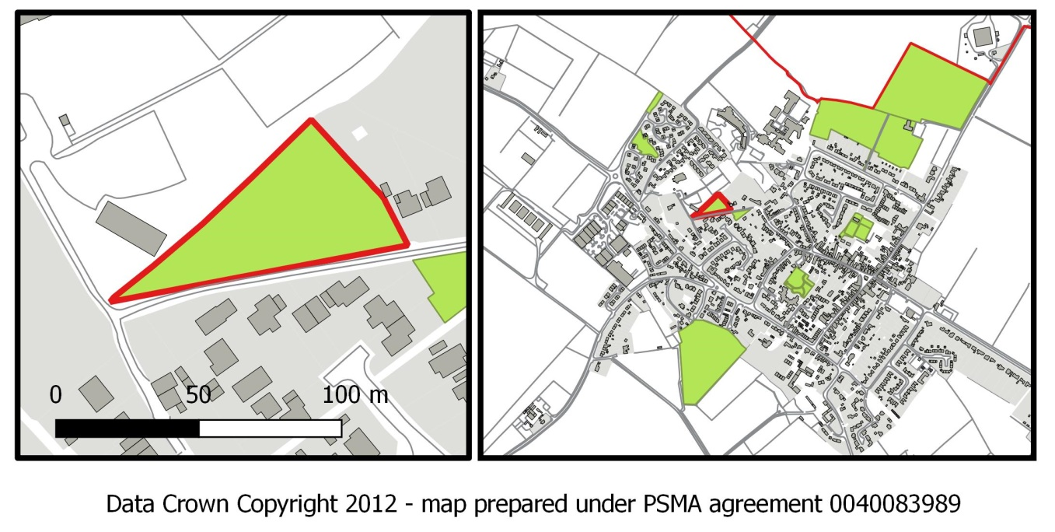
Site Details
Marlbrook Green | SU684948 | Open public grass area in the middle of a 1980’s housing development, used as local play area. Owned by the Parish Council.
Checklist
Statutory designations |  | Site allocations | Planning permissions
No designation |  | This NDP recommends site for allocation as Local Green Space | Land planned as open green area when Marlbrook Estate was developed in 1985.
NPPF Criteria
Close to the community |  | Demonstrably special | Local and not extensive
On the western edge of the built-up area of the town with houses around three sides. The open edge of the area faces onto one of the designated development sites (site B) allocated in this plan. It is hoped that development of site B will integrate into the form of Marlbrook, so that the combined unit becomes less isolated from the rest of the community. |  | This was planned as a green space for use by the residents of Marlbrook at the time that it was built. It has since had some trees planted in groups to provide some features to an otherwise open grassed area. It is well used by children of the area for outdoor play throughout the year. | The area is part of the design for Marlbrook. It has an area of less than 0.2 ha. The aim of proposing it as a Local Green Space is to protect it as a natural asset for future generations.
