^{Post Examination Version}

‘Our Community… Our Plan’
Watlington Parish Council
April 2018

Document:
WNDP 2

Basic Conditions Statement

Watlington Town Hall

Contents
1. INTRODUCTION AND BASIC CONDITIONS 5
1.1 Qualifying Statement 5
1.2 Designated Neighbourhood Area. 5
1.3 Why Watlington needs a Neighbourhood Development Plan 7
1.4 Planned growth of Watlington 7
1.5 Basic Conditions 7
2. CONFORMITY WITH NATIONAL POLICIES AND GUIDANCE 8
2.1 National Planning Policy Framework (NPPF). 8
2.2 National Planning Practice Guidance (PPG): 8
3. CONTRIBUTION TO SUSTAINABLE DEVELOPMENT 13
3.1 Concept of Sustainable Development 13
3.2 The WNDP meets the need for sustainable growth in the following ways: 13
3.3 Sustainability Appraisal Scoping Report and Sustainability Appraisal/Environmental Report 13
3.4 Assessment of the Plan 14
4. CONFORMITY WITH SOUTH OXFORDSHIRE DEVELOPMENT PLANS 15
4.1 Conformity with SODC Core Strategy 2012 15
4.2 Conformity with the saved policies in the SODC Local Plan 2011 16
4.3 Conformity with the emerging SODC Local Plan 2033 17
5. conformity with EU obligations 20
5.1 European Convention on Human Rights (ECHR) 20
5.2 Strategic Environmental Assessment (SEA) 21
5.3 Impact on European Sites: Habitats Regulations Assessment 21
5.4 Air Quality Directive (2008/50/EC) 23
6. REGULATION 14 CONSULTATION 24

Figures
Figure 1 : Designated WNDP Area 2013 5
Figure 2 : Designated WNDP Area 2015 6

Maps
All maps contain Crown Copyright Data ©, Crown Copyright and Database Right [2012] and have been prepared by Watlington Parish Council under the PSMA agreement 0040083989. These maps may not be reproduced in any form without explicit approval from Ordnance Survey Limited and Watlington Parish Council.

Tables
Table 1: Conformity with the National Planning Policy Framework (NPPF) and National Planning Practice Guidance (NPPG) 9
Table 2: Conformity with SODC Core Strategy 2012 15
Table 3: Conformity with the emerging South Oxfordshire Local Plan 2033 17
Table 4: SEA Directive Issues 21

INTRODUCTION AND BASIC CONDITIONS

Qualifying Statement
This Statement has been prepared by Watlington Parish Council, as the qualifying body, to accompany the submission of the Watlington Neighbourhood Development Plan (WNDP) to South Oxfordshire District Council (SODC) under regulation 15 of the Neighbourhood Planning (General) Regulations 2012. The WNDP has been prepared by the Watlington Neighbourhood Development Plan Forum, a community group established under the auspices of the Parish Council (not the same as a Forum in a parish without a parish council). The work of the Forum has been overseen by a parish council committee – the Neighbourhood Plan Steering Committee.
The WNDP covers the period 2017 to 2033. The period has been chosen to align with the dates of the emerging South Oxfordshire Local Plan. Guidance in the National Planning Practice Guidance (PPG) Neighbourhood Planning has been followed throughout the process of developing the WNDP.

Designated Neighbourhood Area.
In October 2013 SODC approved all land within the parish boundary as the Designated Area for the WNDP. This followed a year-long discussion between the Parish Council, SODC officers, SODC councillors and the Parish Councils (or Meetings) of Pyrton, Cuxham and Britwell Salome.
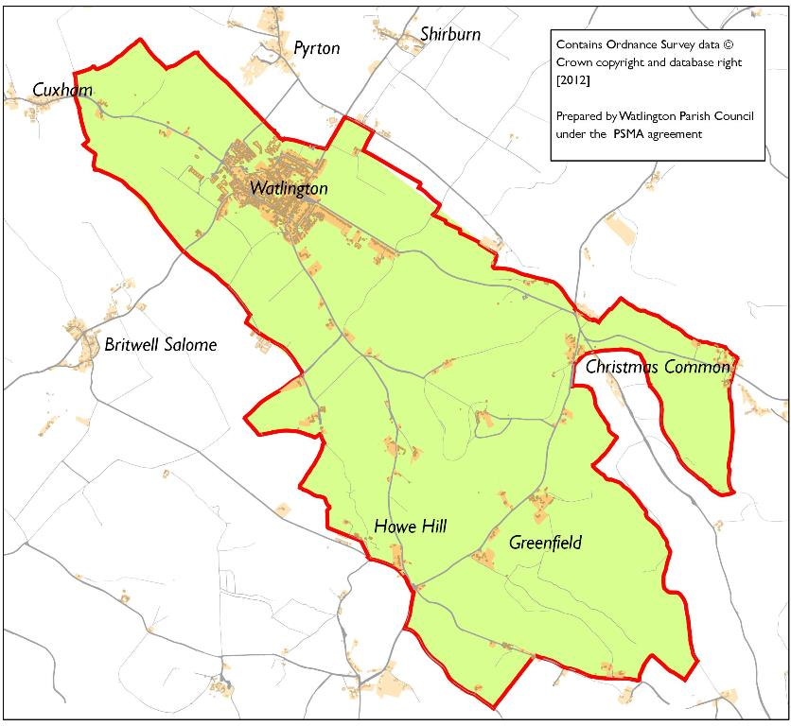

Figure 1 : Designated WNDP Area 2013
In 2015 Watlington Parish Council (WPC) submitted a new application for the re-designation of a Neighbourhood Development Plan area in accordance with Regulation 5 of the Neighbourhood Planning (General) Regulations 2012. The area specified includes the whole parish, as amended by parish boundary changes in April 2015. WPC made the application as a result of the parish boundaries review in order to maintain the conformity of the emerging policies and proposals within the WNDP area indicated.
The parish of Watlington was formally re-designated as a Neighbourhood Area and approved by SODC on 15 October 2015.
The WNDP designated area includes the settlement of Watlington itself, and the three outlying settlements of Christmas Common, Greenfield, Howe Hill, and parts of Northend and Pishill. The outlying settlements contain about 15% of the Neighbourhood Area population. Where relevant, policies in WNDP relate to these settlements.

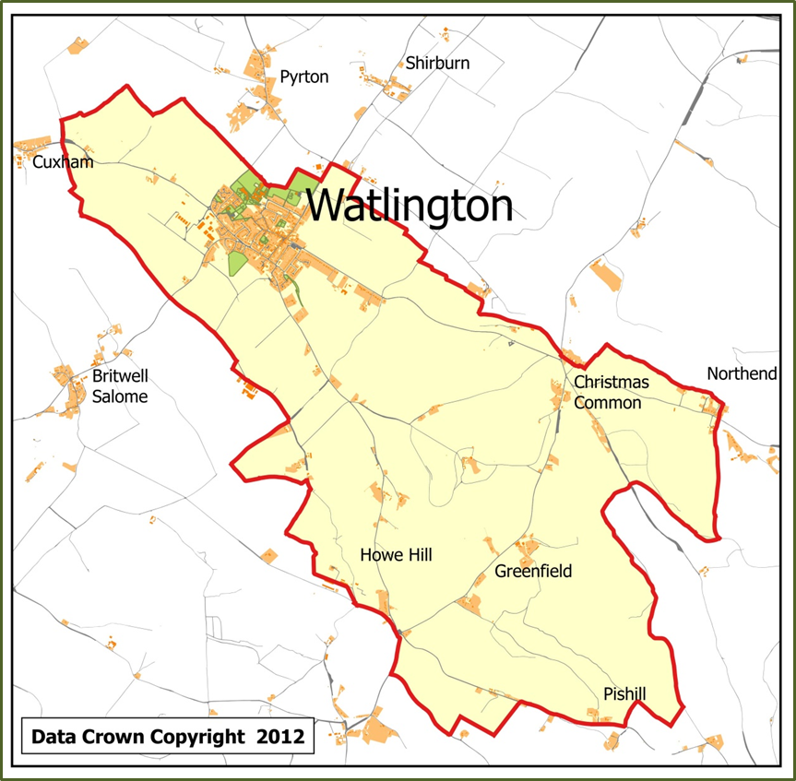

Figure 2 : Designated WNDP Area 2015

Why Watlington needs a Neighbourhood Development Plan
A Neighbourhood Development Plan gives residents of Watlington Parish a way of influencing planning decisions which will be needed to steer anticipated growth in the number of homes locally. It can help to develop a shared vision for the town of Watlington, select the sites most suitable for development, define preferences for the mix of housing types, and give protection to the most important amenity and environmental features of the area. It meets the NPPF core principle (paragraph 17) of empowering local people to shape their surroundings. Because the Local Planning Authority must have regard for a legally approved Neighbourhood Development Plan, the future of Watlington can, to a considerable extent, be shaped by the wishes of the community. In addition, the emerging SODC Local Plan 2033 articulates a District Council wish for new housing sites to be identified primarily through Neighbourhood Plans.

Planned growth of Watlington
The WNDP makes provision for the growth of Watlington by allocating 3 sites for development to accommodate a minimum of 238 new homes. In addition, provision is made for other identified sites to come forward for specific housing purposes during the period of the Plan. The minimum of 238 new homes is in accordance with provision in the emerging SODC Local Plan 2033 and contribute to the objectively assessed needs of the district. This number is equivalent to an increase in housing stock of 15% allocated to each of the larger villages in the District (including Watlington) and takes account of planning approvals granted between 2011 and 2017.
The WNDP includes proposals for development which are in line with NPPF16. The development plans support the strategic policies for housing and economic development set out in the emerging SODC Local Plan 2033 and also include policies for local development which are outside the strategic elements of the Local Plan.

Basic Conditions
This Statement addresses the basic conditions set out in paragraph 8 (2) of Schedule 4B to the Town and Country Planning act 1990 as applied to neighbourhood plans by section 38A of the Planning and Compulsory Purchase Act 2004.

The basic conditions are:
- Having regard to national policies and advice contained in guidance issued by the Secretary of State it is appropriate to make the Neighbourhood Development Plan.
- The making of the Neighbourhood Development Plan contributes to the achievement of sustainable development.
- The making of the Neighbourhood Development Plan is in general conformity with the strategic policies contained in the development plan for the area of the authority (or any part of that area).
- The making of the Neighbourhood Development Plan does not breach, and is otherwise compatible with, EU obligations.

CONFORMITY WITH NATIONAL POLICIES AND GUIDANCE

National Planning Policy Framework (NPPF).
All relevant policies on plan-making have been considered and those which have specifically informed the WNDP are included in Table 1.

National Planning Practice Guidance (PPG):
The areas of guidance which have been particularly relevant to the WNDP, in addition to the guidance on Neighbourhood Planning are:
- Air quality (WNDP Policy P2 )
- Conserving and enhancing the historic environment (WNDP Policy P1 )
- Design (WNDP Policy P1)
- Ensuring the vitality of town centres (WNDP Policy P6 )
- Flood risk (and coastal change) (WNDP Policy P3 )
- Health and wellbeing (WNDP Policy P2, P4, P5, P8 )
- Light pollution (WNDP Policy P3 )
- Natural environment (WNDP Policy P3 )
- Open space, sports and recreation facilities, public rights of way and local green space (WNDP Policy P4, P5, P8, P9 )
- Rural housing (WNDP Policy P5 )
- Self-build and custom housebuilding (WNDP Policy P5)

Table 1: Conformity with the National Planning Policy Framework (NPPF) and National Planning Practice Guidance (NPPG)

WNDP Policy number | Policy | NPPF Paragraph numbers and NPPG references | Commentary
P1 | Protect and enhance the character of Watlington and the historic setting of the town. | 126, 56, 57, 58, 60, 61 also NPPG Conserving and enhancing the historic environment and Design | This policy accords with NPPF policies for good design and conserving and enhancing the historic environment. It seeks to ensure that development makes a positive contribution to the historic character of Watlington and to the designated Conservation Area and other heritage assets. It also plans positively for high standards of design which reflect local distinctiveness.
P2 | Transport, including measures to address air pollution in the town centre | 126, 23,28,29, 30, 31, 40, 124, also NPPG Air Quality, Health and Wellbeing, | This policy accords with NPPF policies for ensuring the vitality of town centres, supporting a prosperous rural economy, promoting sustainable transport and conserving and enhancing natural and historic environments. It addresses the need to reduce congestion in the town centre in order to improve air quality in the designated Air Quality Management Area and reduce the adverse impact of traffic on historic buildings. It proposes to safeguard land for new highway infrastructure in order to support sustainable development. Planned improvements to the town centre as a result of the proposed changes are intended to contribute to the vitality of the town centre and facilitate growth in the local economy. Additional provision for town centre parking is also proposed to meet this objective.
WNDP Policy number | Policy | NPPF Paragraph numbers and NPPG references | Commentary
P3 | Conserve and enhance the natural environment | 100, 103,109, 110, 113 114, 115, 118, 125 also NPPG Natural environment and Flood risk and Light pollution | This policy accords with NPPF policies for flooding and conserving and enhancing the natural environment. The policy aims to protect local chalk streams and manage natural flows in order to reduce the risk of flooding. In line with NPPF 100 and footnote 20 Sequential Tests and Site Specific Flood Risk Assessments have been carried out (WNDP 14). Watlington is in a very sensitive location on the boundary of the Chilterns AONB at the foot of the Chilterns escarpment and this policy aims to ensure that views of and from the AONB are protected. In addition it aims to protect and enhance biodiversity and limit impact on wildlife by reducing light pollution.
P4 | Green Spaces | 70, 73, 74, 75, 76, 77 also NPPG Open space, sports and recreation facilities, public rights of way and local green space and Health and wellbeing. | This policy accords with NPPF policies for promoting healthy communities. It seeks to designate areas as Local Green Spaces which provide a significant local amenity and/or have biodiversity value in order to contribute to the health and wellbeing of residents. It also seeks to ensure that provision is made on developments of 10 or more new houses for green spaces for amenity areas and recreation.
P5 | New housing development | 47, 50, 55, 69, 70, 93, 95, 97 also NPPG Rural housing, Self-build, Health and wellbeing and Open space. | This policy accords with NPPF policies for delivering a wide choice of high quality homes, promoting healthy communities and meeting the challenge of climate change. The policy aims to boost the supply of homes and enhance the vitality of the community by meeting the identified need for affordable homes and providing a good mix of housing types. The policy provides for an integrated approach to housing, shops, local services and facilities via safe and accessible routes for pedestrians and cyclists. It also encourages measures which provide resilience to the effects of climate change through reductions in the use of resources and the use of energy generation schemes.
WNDP Policy number | Policy | NPPF Paragraph numbers and NPPG references | Commentary
P6 | Enhance Watlington as a service centre | 23, 28, 70 also NPPG Ensuring the vitality of town centres | This policy accords with NPPF policies for ensuring the vitality of town centres, supporting a prosperous rural economy and promoting healthy communities. It recognises that the town centre is the heart of the community and seeks to retain and enhance existing shops and businesses. It encourages sustainable rural tourism and leisure activities appropriate to the character of Watlington which will benefit the community and visitors and provide some local employment opportunities.
P7 | Employment | 28 | This policy accords with the NPPF policy for supporting a prosperous rural economy. It promotes economic growth by providing opportunities for additional jobs and businesses which respect the character of the countryside. It encourages small scale local growers and secondary food producers as they have a potential to increase employment and add to the resilience of the local economy.
P8 | Physical and social infrastructure | 28, 29, 42, 69, 70, 72 also NPPG Health and wellbeing, Open space and recreation facilities, public rights of way and local green space. | This policy accords with NPPF policies for supporting a prosperous economy, promoting sustainable transport, supporting high quality communications infrastructure and promoting healthy communities. It encourages development which includes the retention and development of local services and community facilities. It recognises the need for local schools to expand and for local connectivity to improve by increasing provision of broadband and improving safe access to local paths and rights of way.
WNDP Policy number | Policy | NPPF Paragraph numbers and NPPG references | Commentary
Site A | Watlington Housing Policy | 111,112,  173,174 | This policy is linked to WNDP policies P1, P2, P3, P4, P5, P7, and P8. Conformity of these policies with the NPPF and NPPG is listed above. The site allocations also comply with NPPF policies for the consideration of brownfield sites and agricultural land and policies requiring that development proposals are viable and deliverable.
Site B and  Site C | Watlington Housing Policy | 111,112,  173,174 | These policies are linked to WNDP policies P1, P2, P3, P4, P5, and P8. Conformity of these policies with the NPPF and NPPG is listed above. The site allocations also comply with NPPF policies for the consideration of brownfield sites and agricultural land and policies requiring that development proposals are viable and deliverable.

CONTRIBUTION TO SUSTAINABLE DEVELOPMENT

Concept of Sustainable Development
The WNDP embraces the concept of sustainable development in accordance with NPPF 14, 15, 16 and 17 and ways to promote economic, social and environmental sustainability have been considered throughout the process of developing the Plan. In line with NPPF 9, the WNDP has looked for opportunities to improve the quality of the built, natural and historic environment, as well as in people’s quality of life including:
- Making it easier for jobs to be created
- Moving from a net loss of bio-diversity to achieving net gains for nature
- Replacing poor design with good design
- Improving the conditions in which people live, work, travel and take leisure
- Widening the choice of high quality homes

The WNDP meets the need for sustainable growth in the following ways:
- It seeks to enhance and improve the places in which people live their lives. (WNDP Policies P1, P2, P3, P4, P5, P8)
- It supports economic development. (WNDP Policies P6, P7)
- It seeks to secure high quality design for new sites and buildings and good standards of amenity for new and existing residents. (WNDP Policies P1, P4, P5, P6, P8)
- It takes account of the different roles and character of different parts of the Plan area, recognises the intrinsic beauty of the countryside and promotes thriving communities. (WNDP Policies (P1, P3, P6)
- It supports the transition to a low carbon future in response to a changing climate. (WNDP Policies (P3, P5)
- It contributes to conserving and enhancing the natural environment and reducing pollution. (WNDP Policies P2, P3, P4)
- It promotes safe routes for cycling and walking. (WNDP Policies P5, P8)
- It aims to deliver community facilities which meet local needs. (WNDP Policies P8)

This approach to plan making accords with the core planning principles in NPPF 17.

Sustainability Appraisal Scoping Report and Sustainability Appraisal/Environmental Report
A Sustainability Appraisal Scoping Report (WNDP 5), which includes a Strategic Environmental Assessment (SEA) was produced in January 2017. Further information on the SEA is included in Section 5. The Scoping Report was sent for comments to bodies including the Environment Agency, Historic England, Natural England and The Chilterns Conservation Board. Feedback from these bodies was incorporated into the Sustainability Appraisal/Environmental Report which was included in the pre-submission consultation on the WNDP which ran for a six week period between 18th April, 2017 and 2nd June 2017. Amendments were made to the document as a result of further comments by the statutory consultees.

Assessment of the Plan
The WNDP objectives and policies were assessed against the Sustainability Objectives (Appendix A) using an agreed framework. Alternative options for development were assessed using the same framework and details are included in the Sustainability Appraisal (WNDP 4) and the Development Sites Topic Paper (WNDP 12). An analysis of the likely effects of WNDP policies together with recommendations for mitigation measures is also included in the SA document.
The main mitigation measures identified as a result of selecting sites for development are:

- The loss of farmland, as greenfield development sites, will be mitigated by the provision on the sites of green spaces to be used as allotments, community gardens, a community orchard or areas for informal recreation.
- Net gains in biodiversity will be sought through the provision of habitat linkages and corridors for wildlife.
- The impact of a new road crossing a chalk stream will be mitigated by the provision of a wetland and wildlife area.
- The impact of development on the dark skies around Watlington will be mitigated by sensitive lighting schemes which have the least environmental impact.

CONFORMITY WITH SOUTH OXFORDSHIRE DEVELOPMENT PLANS

Conformity with SODC Core Strategy 2012
The WNDP is in general conformity with the strategic policies in the SODC Core Strategy 2012. Details are contained in Table 2. The principle applied in the WNDP is in line with PPG Neighbourhood Planning (paragraph 74) and aims to provide ‘an additional level of detail and/or a distinct local approach to that set out in the strategic policy without undermining that policy.’

Table 2: Conformity with SODC Core Strategy 2012

WNDP  Policy number | WNDP Policy | SODC Core Strategy (CS)Policies | Commentary
P1 | Protect and enhance the character of Watlington and the historic setting of the town | CSEN1, CSEN3, CSQ3 | This policy conforms with CS policies for the Historic Environment and Design. It adds local distinctiveness to the core SODC policies
P2 | Transport | CSM1 | This policy conforms with the CS policy for Transport, particularly in relation to the proposals for improving air quality and for car parking.
P3 | Conserve and enhance the natural environment | CSEN1, CSG1, CSB1, | This policy conforms with CS policies for Landscape, Green infrastructure and biodiversity. It provides a local context and specific local proposals.
P4 | Green Spaces | CSG1 | This policy conforms with the CS policy for Green infrastructure and biodiversity. It provides local context and detail.
P5 | New housing development | CSH1, CSH2, CSH3, CSH4 | While these policies are out of date, the WNDP policy on housing is in general conformity with them, particularly with regard to the provision of affordable housing.
P6 | Enhance Watlington as a service centre | CSEM1, CST1, CSR2 | This policy conforms with the provision in these policies for supporting tourism, local centres and shopping and support for reinforcing local distinctiveness.
WNDP  Policy number | WNDP Policy | SODC Core Strategy (CS)Policies | Commentary
P7 | Employment | CSEM2, CSEM4, CSR2 | This policy conforms with the provision in these policies for new employment sites, for supporting home workers, for tourism businesses based on the character of the area and for agricultural diversification.
P8 | Physical and social infrastructure | CSM1, CSR3, CSI1 | This policy conforms with the provision in these policies for the encouragement of facilities and services in rural areas, for the encouragement of cycling, walking and rural transport initiatives and for support for appropriate on- and off-site infrastructure and services to meet the needs of new development.
Site A | Watlington Housing Policy |  | This policy is derived from the WNDP policies P1, P2, P3, P4, P5, P7 and P8 and comply with the Core Strategy policies identified above.
Site B  Site C | Watlington Housing Policy |  | These policies are derived from the WNDP policies P1, P2, P3, P4, P5, and P8 and comply with the Core Strategy policies identified above.

Conformity with the saved policies in the SODC Local Plan 2011
The WNDP also complies with relevant saved policies in the Local Plan 2011 regarding the following:
- Protection of the landscape and countryside: G2, G4 and C6.
- Biodiversity: C6 – C9.
- Conservation Areas, historic buildings and archaeological remains: Con 1 – Con 16.
- Environmental protection: EP1 – EP7.
- Good design: D1 – D5 and D7.
- Housing: H4, H10, H13, H15, H16.
- Recreation: R1, R2, R6 – R8.
- Safeguarding community facilities: CF1 – CF3.
- Employment regarding home workers: E7
- Tourism: TSM1, TSM2.
- Transport: T1, T2, T7, T8

Conformity with the emerging SODC Local Plan 2033
As the policies for housing development contained in the Core Strategy are out of date, the WNDP conforms to the relevant policies in the emerging SODC Local Plan 2033 Publication Version October 2017 (SOLP).
Watlington is identified by SODC as a ‘larger village’ and is named in The Overall Strategy of the SOLP, Policy STRAT1. This policy includes supporting and enhancing the role of the larger villages as local service centres as a key component of development in the district. Policies in the WNDP comply with this and seek to develop the social and economic sustainability of the town to meet the growing needs of Watlington and the surrounding area. Planned housing growth in the WNDP is in line with SOLP Policy H4 which provides for a minimum of 1,122 homes to be collectively delivered by the larger villages in the district. This contributes to the objectively assessed housing needs of the district. SOLP Table 5g shows that a 15% growth of dwellings in Watlington is equal to 238 new homes to be provided over the period to 2033. The WNDP makes provision for a minimum of this number on allocated development sites and also supports specific additional development for extra care provision for older people, staff accommodation at the Watlington and District Nursing Home, additional park homes and rural exception sites to come forward during the period of the Plan. It is expected that the potential housing allocation for Watlington indicated in the SOLP of between 200 and 400 will be met as the sites identified in the WNDP are available for development and are deliverable during the period of the Plan.
Table 3: Conformity with the emerging South Oxfordshire Local Plan 2033

WNDP Policy number | Policy | SODC emerging Local Plan  (LP) policies | Commentary
P1 | Protect and enhance the character of Watlington and the historic setting of the town | ENV1, ENV6, ENV 7, ENV 8, ENV9, DES1, DES2 | This policy complies with Local Plan (LP) policies for landscape, the countryside and the attractive landscape setting of settlements. The policy provides a local context for LP policies for the historic environment, Conservation Areas and for archaeological remains. It complies with LP policies for design, especially in its aim to ensure that design is locally distinctive and enhances local character.
P2 | Transport | TRANS1, TRANS3, EP1 | This policy complies with LP policies for the delivery of safeguarded transport improvements to help deliver the development required in the plan period and beyond. In particular, it complies with the policy to safeguard land for strategic transport schemes which include a bypass for Watlington. It also complies with policy EP1 which seeks to protect public health from the impacts of poor air quality.
WNDP Policy number | Policy | SODC emerging Local Plan  (LP) policies | Commentary
P3 | Conserve and enhance the natural environment | ENV1, ENV2, ENV3, ENV4 | This policy complies with LP policies on biodiversity and seeks to achieve a net gain in biodiversity as a result of development. It also provides a local context for the policy on watercourses.
P4 | Green spaces | ENV5, DES5, CF3, CF4, CF5 | This policy complies with LP policies for green infrastructure. It seeks to provide outdoor amenity spaces on new development and to protect existing open spaces.
P5 | New housing development | H1,H9,  H11, H12,  TRANS2,  TRANS5,  DES8, DES9  DES10 | This policy complies with LP policies for housing. It aims to provide 40% affordable homes on sites of 11 or more dwellings, subject to the viability of the provision on each site. It promotes a mix of dwelling types and sizes including plots for self-build. It encourages provision for walking and cycling, not only within new development but also to nearby facilities and services. It also promotes the installation of renewable energy schemes.
P6 | Enhancing Watlington as a service centre | STRAT1,  EMP11,  EMP12, TC1, TC3 | This policy complies with LP policies for supporting and enhancing the role of the larger villages as local service centres. It supports sustainable rural tourism which respects the character of the countryside and it promotes the retention and development of services including local shops and public houses. It aims to retain primary retail frontages in line with policy TC3 in order to ensure the continued economic vitality of the town centre.
P7 | Employment | EMP2, EMP11  EMP12 | This policy complies with LP policies for employment. It makes proposals for premises suitable for small and medium sized businesses and also promotes the diversification of agricultural businesses including local growers and secondary food producers.
WNDP Policy number | Policy | SODC emerging Local Plan  (LP) policies | Commentary
P8 | Physical and social infrastructure | INF1,  INF2, TRANS2, TRANS5, CF2, CF3,  CF5 | This policy complies with several LP policies including infrastructure, transport and community facilities. It promotes the retention and development of community facilities including meeting places and sports venues. It identifies infrastructure to meet the needs of new development and to mitigate the impact of development. It requires the provision of safe and convenient routes for cyclists and pedestrians and encourages rural transport initiatives. It also complies with communications proposals in policy INF2 for superfast broadband.
Site A  Site B  Site C | Watlington Housing Policies | H1,H4, | These policies relate to LP policies which give approval for sites identified for new homes in Neighbourhood Development Plans. These WNDP policies are derived from policies P1, P2, P3, P4, P5, P7 (Site A only) and P8 and also comply with the LP policies identified above.

conformity with EU obligations

European Convention on Human Rights (ECHR)
Neighbourhood Development Plans are required to have been produced in conformity with, and not to breach, the ECHR, which has been incorporated into UK law through the Human Rights Act 1998.
‘Convention Rights’, as they are known, are widely drawn, but the ones most related to town and country planning - and hence to NDPs - are set out in the Convention’s Article 6(1), Article 8, Article 14 and the First Protocol Article 1.
Article 6(1) - Right to a fair trial.
Watlington NDP has been prepared in a wholly fair and transparent manner. Membership of all bodies and groups involved in preparing the Plan have been published on the WNDP website, which has itself been widely publicised in the local area. All meeting notes have been published on the website in a timely fashion. Relevant meetings of the Watlington Parish Council have been held in public and meeting records placed on its website. Further details can be found in the Consultation Statement (WNDP 3).
Article 8 - Right to respect for private and family life.
All 3 major community consultations held in connection with WNDP, and the Watlington Housing Survey 2016, have guaranteed and respected the anonymity of respondents. Additional written comments received by the WNDP team have been anonymised except where permission has been received to do otherwise.
Article 14 - Prohibition of Discrimination
WNDP does not discriminate in any way in respect of the needs of its current and potential future citizens. Indeed, the Plan policies make provision for housing development which should make appropriate provision for all age groups, for people with physical and sensory disabilities, for families with children and for households of different sizes. Watlington is likely to become a more diverse community in future and WNDP respects this. The Watlington Traffic Management Strategy (WNDP 13), which accompanies the Plan, is committed to the health, safety and mobility of all sections of the community.
First Protocol Article 1 - Protection of Property
Nothing in WNDP breaches or seeks to breach any individual or corporate property rights. Watlington Parish Council is not a primary local authority and has no rights of compulsory purchase or other statutory rights over private property.

Strategic Environmental Assessment (SEA)
SODC issued a screening opinion in February 2015 that an SEA would be required as the Watlington NDP is likely to have significant environmental effects and will allocate preferred sites for development. This is in conformity with the Strategic Environmental Assessment Directive 2001/42/EC transposed into UK law through the Environmental Assessment of Plans and programmes regulations 2004. The assessment was incorporated into the Sustainability Appraisal Scoping Report (WNDP 5) which was produced and consulted on in January 2017. Sustainability objectives (Appendix A) developed for the WNDP were cross-checked against SEA Directive issues. Table 4 is included in the Sustainability Appraisal with Environmental Report (WNDP 4). The Report was consulted on as part of the Regulation 14 pre-Submission Consultation (Consultation 3) and some minor additions and changes were made as a result of comments from statutory consultees.
Table 4: SEA Directive Issues

SEA Directive issue | NDP Sustainability Objectives
Biodiversity, fauna and flora | Objectives 8, 9, 10, 19
Human population | Objectives 1, 2, 3, 17, 20, 21
Human health | Objectives 4, 5, 6
Soil | Objectives 8, 18, 19
Water | Objectives 15, 16
Air quality and climate | Objectives 7, 13, 14
Material Assets | Objectives 11, 12
Cultural heritage | Objectives 11, 12, 22
Landscape | Objectives 9, 10

Impact on European Sites: Habitats Regulations Assessment
SODC has made an assessment of the impact of development in the district, including Watlington, regarding the EU Habitat Directive Sites or Species. This has been done in the South Oxfordshire Local Plan: Habitats Regulations Assessment Report March 2017. SODC also commissioned a screening report on the impact of development proposed in the WNDP on EU Special Areas of Conservation (SACs) and this was completed in December 2017 (WNDP 15). The screening report concludes the following:
The HRA screening of the Watlington Draft Neighbourhood Development Plan (August 2017) has been undertaken in accordance with currently available guidance and based on a precautionary approach as required under the Habitats Regulations.
The HRA screening has concluded that likely significant effects on the integrity of European sites around South Oxfordshire from policies and site allocations in the Local Plan will not occur in relation to:
- Physical loss of or damage to habitat;
- Non-physical disturbance: noise, vibration and light pollution; or
- Water quantity and quality.
In addition, none of the policies or site allocations in the Neighbourhood Plan is considered likely to result in significant effects on the European sites within 17km of Watlington, due to air pollution or recreation pressure.
Four policies and site allocations that would result in new homes were identified as having uncertain effects on Aston Rowant SAC due to increased visitor numbers, and uncertain effects on Aston Rowant SAC and Chilterns Beechwoods SAC due to increased traffic and air pollution:
- Policy P5. New housing development (small scale development of up to five homes);
- Site A - Land between Britwell Road and Cuxham Road - c.140 homes and a small number of workshops and/or offices for small businesses or start ups;
- Site B - Land Off Cuxham Road and Willow Close - c.38-60 homes; and
- Site C - Land off Pyrton Lane - c.60 homes.
Data on commuting by car indicates that people living in Watlington travel to a number of locations for work, with Henley-on-Thames receiving a slightly higher proportion than other locations. Very few journeys would require use of the A404 or A4010 in the direction of Chilterns Beechwoods SAC. Although a small proportion of journeys are likely to involve the M40 (for example those in the direction of London), which would pass Aston Rowant SAC, the overall quantum of development proposed at Watlington would not increase traffic flows by more than 1000 AADT on the M40.
Travel to Watlington for work comes from a spread of locations, with a slightly higher proportion of trips from Benson, Newington and Chinnor. Very few journeys are made to Watlington from the direction of roads adjacent to Chilterns Beechwoods SAC or Aston Rowant SAC. Watlington Neighbourhood Plan alone is therefore unlikely to significantly increase traffic, and therefore air pollution, adjacent to sensitive European sites. The Neighbourhood Plan does, however, have the potential to have impacts on air pollution in combination with other plans.
The Council may rely upon the conclusions of the recent HRA of the emerging Local Plan in respect of the potential effects of traffic related air pollution. The assessment concluded that the in-combination effects of growth could have likely significant effects on the Aston Rowant SAC, however an appropriate assessment of those effects has confirmed that they would not result in an adverse effect on the integrity of the site, and as such no further appropriate assessment of the Watlington Neighbourhood Plan is required.
Potential effects of recreational pressure on Aston Rowant SAC have been screened out of the Local Plan HRA, and it would be appropriate for the Council to rely on the conclusion of that recent HRA in screening the Watlington Neighbourhood Plan, and as such it may be concluded that Watlington Neighbourhood Plan would not have any likely significant effects on Aston Rowant SAC through recreational pressure and no appropriate assessment is required.

Air Quality Directive (2008/50/EC)

The centre of Watlington was designated by SODC as an Air Quality Management Area in 2009 because levels of pollution were consistently above the levels set by the EU. SODC published an Air Quality Action Plan (AQAP) in 2014 and a Low Emissions Strategy (LES) in 2017. The main source of pollution is vehicle emissions. The WNDP seeks to support the aims of the AQAP and the LES and includes proposals for the reduction of air pollution by reducing the volume of traffic using town centre roads. The WNDP reserves land on the allocated development sites for a safeguarded route for a re-aligned B4009 which would divert a majority of through traffic away from the town centre.

REGULATION 14 CONSULTATION
Under Regulations 14 and 21 of the Neighbourhood Plan (General) Regulations 2012 (as amended), a Qualifying Body must publicise the draft Neighbourhood Development Plan for at least 6 weeks, and consult any of the Consultation Bodies (specified in Schedule 1 of the Regulations) whose interests it considers may be affected by the draft Plan.
Watlington Parish Council, as the qualifying body, ran a pre-Submission consultation between 18 April 2017 and 2 June 2017. The draft WNDP was sent to those Consultation Bodies whom WPC decided were relevant to planning matters in Watlington. The draft WNDP was published on the Neighbourhood Plan website, a summary of the WNDP Policies was hand-delivered by volunteers to every residential household and to business premises in the WNDP Area, with a questionnaire for return to the WNDP Office.
Over 520 questionnaires were returned from households and businesses. In addition to the checklist responses, over 1100 additional written comments were received. These were recorded, tabulated and analysed and appropriate adjustments to the Plan have been made in the light of these comments.
WPC is satisfied that it has met the requirements of the Regulations and guidance in PPG Neighbourhood Planning. The draft WNDP has been extensively publicised and consulted upon. Relevant comments from Statutory Consultees and local households and businesses have been properly considered and fed into the final drafting of the Plan. The Parish Council, as Qualifying Body, believes that the Draft WNDP as submitted to SODC, represents the settled opinion of the community on the basis of the information available to the Plan Team at the time of the Consultation and communicated to the community of Watlington. Full details of the consultation process and outcomes are included in the Consultation Statement (WNDP 3) and are on the WNDP website.

- WNDP Sustainability Objectives
Extract from the Sustainability Appraisal with Environment Report (WNDP 4)
# | Sustainability Objective
SO1 | To help to provide a good mix of housing types to meet the identified needs of Watlington residents and to provide the opportunity for people to live in a decent home which is affordable within their means
SO2 | The help to create a safe environment through well designed development in which people can live and work and which is attractive and welcoming to visitors
SO3 | To enable everyone to contribute to decisions affecting the community and to support community initiatives that will benefit local residents
SO4 | To promote people's health and wellbeing by making sure that everyone has good access to local green spaces, to the countryside and to surrounding villages via attractive pedestrian and cycle routes
SO5 | To improve accessibility for people of all abilities to local services and facilities and to promote improved opportunities for public transport
SO6 | To reduce the negative impact of traffic on the environment caused by noise, vibration, and congestion by promoting effective traffic management strategies
SO7 | To support action to improve air quality
SO8 | To conserve and enhance biodiversity ,maximising opportunities for biodiversity within all new development, and paying particular attention to habitat linkage and wildlife corridors
SO9 | To protect and enhance the town's landscape setting and the countryside around it with special regard to the Chilterns AONB
SO10 | To protect the rural character of the parish by minimising light encroachment in order to preserve dark skies
SO11 | To protect and enhance the town's historic environment, Conservation Area and heritage features including archaeological sites
SO12 | To ensure that new development reflects the distinctiveness of the built form of Watlington by using high quality design and materials
SO13 | To ensure that the location and design of new development is resilient to the effects of climate change and to mitigate and adapt to climate change by securing sustainable building practices which conserve energy, water resources and materials
SO14 | To support energy generation projects from renewable sources
SO15 | To protect, enhance and manage the parish's watercourses, springs and ponds. To safeguard their margins and groundwater sources, restoring naturalised sections and creating wetland features where appropriate & improve water quality taking into consideration the requirements of The Water Framework Directive and the Thames River Basin Management Plan
SO16 | To reduce the risk of damaging groundwater or fluvial flooding by taking advantage of natural processes in the way flows are managed and ensuring that sustainable drainage systems are used on sites which are developed.
SO17 | To support the reduction of waste through recycling, composting and energy recovery
SO18 | To improve efficiency in land use through re-use of previously developed land and existing buildings and to protect minerals and other natural resources
SO19 | To safeguard and enhance opportunities for local food production by protecting the best and most versatile agricultural land, small holdings and allotments and facilitating other initiatives such as community orchards and gardens
SO20 | To promote the development of local businesses which are appropriate in scale to the rural context of Watlington and provide increased employment opportunity
SO21 | To support provision for home workers together with support networks for small businesses
SO22 | To support the growth of Watlington as a thriving commercial hub in maintaining and enhancing the vitality of our settlements within the Parish and other nearby communities

UCL’s DataShine Commute: http://commute.datashine.org.uk

