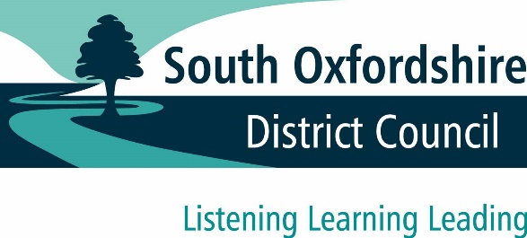

Watlington Neighbourhood Plan

Watlington Parish Council has submitted its Neighbourhood Plan to South Oxfordshire District Council. The submitted plan sets out a shared vision for Watlington and delivers sustainable development through locally specific planning policies.

We are inviting comments on the plan and supporting documents during a publicity period from Wednesday 13 December 2017 to Midnight on Sunday 28 January 2018.

Where to find the Neighbourhood Plan
You can view the Neighbourhood Plan and supporting documents at www.southoxon.gov.uk/watlington
Hard copies of the documents are available to view at Watlington Library (High Street, Watlington), the Parish Council office (1 Old School Place, Gorwell) and South Oxfordshire District Council’s office (135 Eastern Avenue, Milton Park, Abingdon) during usual opening hours.
To submit comments
- visit www.southoxon.gov.uk/watlington and follow links to our online survey
- email us at: planning.policy@southoxon.gov.uk
- write to us at Planning Policy, South Oxfordshire District Council, 135 Eastern Avenue, Milton Park, Abingdon, OX14 4SB.

Please note that you must provide your name and address for your comments to be considered. All responses received will be publicly available on our website and your name may be displayed.
When making your comments, you can request to be notified of South Oxfordshire District Council’s final decision to ‘make’ (formally adopt) the Watlington Neighbourhood Plan.
Further guidance on how to comment is provided on our website.

